Overview
Trigger:
Use this BPP to successfully complete the enrollment into the PrePayment Program using CRM.

Business Process Procedure Overview
Background:
As part of the Smart Energy initiative release R5, customers will have the option of enrolling into the PrePayment program. CSR’s will have the ability to process PrePay enrollments using the Enrollment Center.

Input – Required Fields | Field Value/Comments
- Check account eligibility | CRM will determine if the account is eligible for PrePay on the Enrollment Center. Eligibility messages can be viewed if the account was determined ineligible. Depending on the ineligible message, CSR’s can resolve the eligibility. Text will display stating what actions must be taken.
- Input preferred method | CSR must collect a preferred email from the customer to enroll
- Input critical method  - Submit enrollment | CSR must collect an Email, Voice number, or SMS for the critical method to enroll. Email must be different from the preferred email.  CSR will submit enrollment.

Output - Results | Comments
- PrePay Document created.  - Customer receives confirmation email.  - PayGo enrolls account | In the back office a PrePay document will be created. CSR’s will not have access to view this document.  Customer will receive an enrollment confirmation email letting them know that their enrollment is completed and where they can go to manage their account.  PayGo enrollment completed on their side allowing CSR and customer to access enrolled account.
- Bill consolidator Updated  - Dunning Procedure Updated | Bill consolidator updated to 0008 PrePay Account.  Dunning Procedure update to CMS PrePay Customer Dunning Procedure

Contents

PrePay Enrollment 3
CRM PrePay Link to PayGo site: 18

Procedural Steps
Via Menus | (SAP Menu Path)
CRM7 | Identification / Search -> Enrollment Center -> PrePay/Enroll -> Submit -> Enrollment Triggered
 | (Transaction Code can be displayed by selecting System -> Status)
 | Back Office TCode ZPPM can display the PrePay document.

PrePay Enrollment
This process shows how to perform a PrePay enrollment in CRM
Business Agreement confirmed in CRM. This is done via an incoming call or by manually searching a Business Agreement. 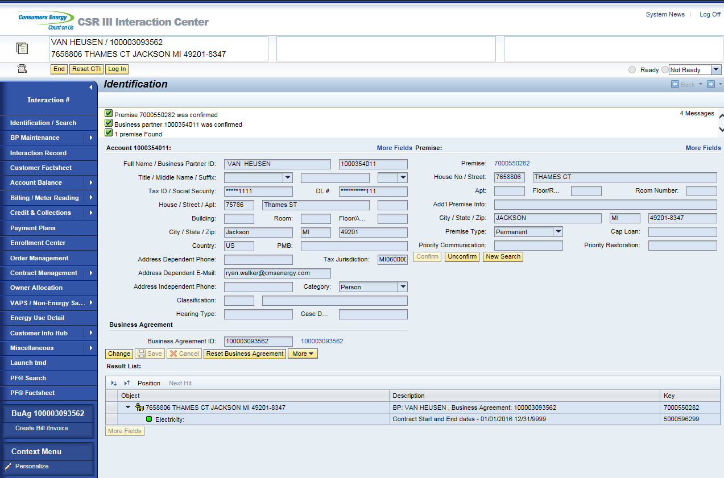
Once Business Agreement is confirmed, the CSR will click on the Enrollment Center from navigation bar. 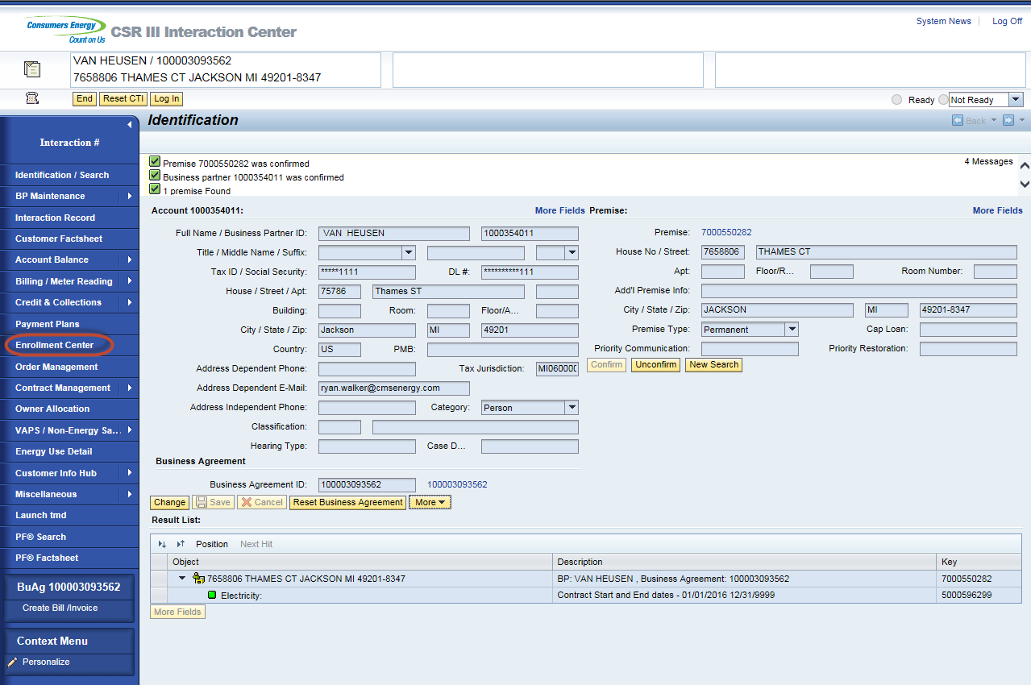
Enrollment Center displays.
- Participating Program section will show the programs the customer is currently enrolled on. It also shows if there is a pending enrollment in process.
- Available Programs section will show the programs that the customer can enroll on. Action column+ will show Enroll when the account has passed validation or Ineligible if the account in not eligible to be enrolled.
- Eligibility messages section will show the messages why the program is ineligible. Clicking on the action eligible will display the reasons under the eligibility message.
- Program History will show the account history if the account has been enrolled previously on a program. Enrollment request date, enrollment date and de-enrollment dates will populate.
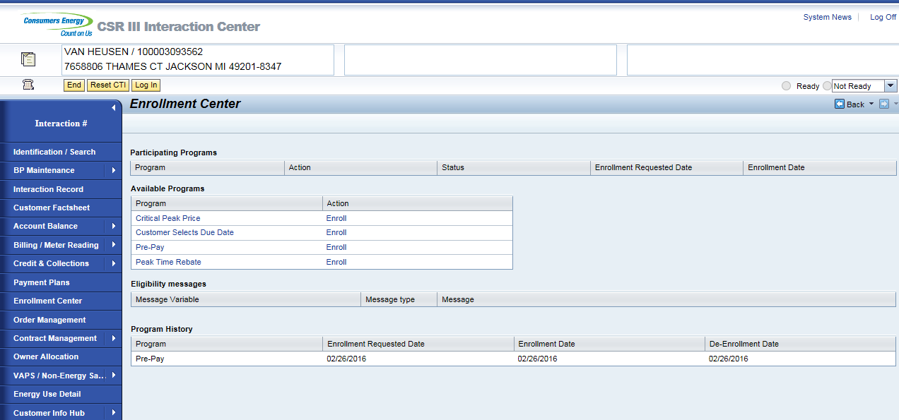
For information about the program, the CSR can click on the program name, which will display the program description. Red X button will close the pop up. PrePay example below. 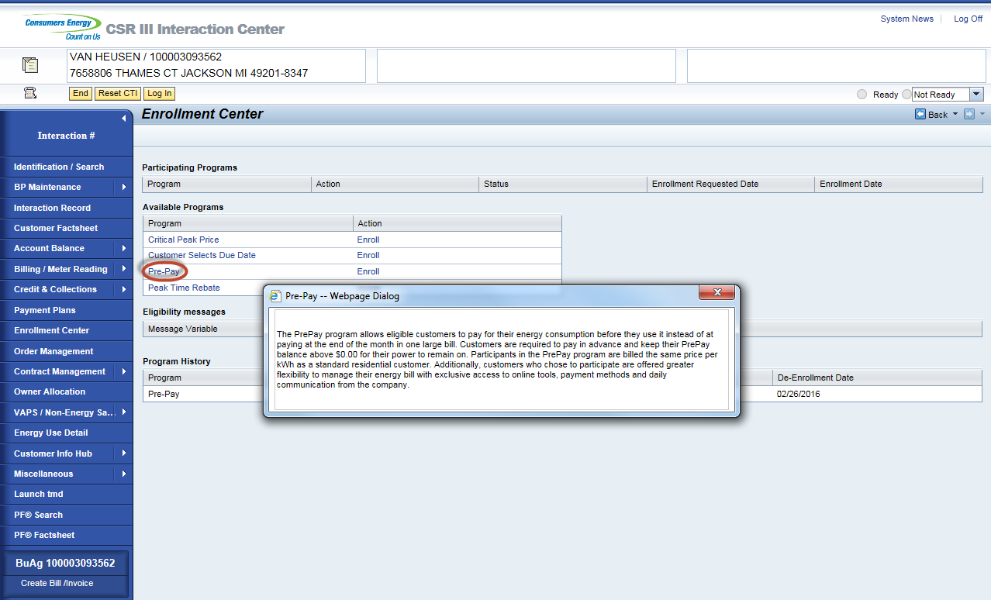
To enroll on Pre Pay click ‘Enroll’ link next to PrePay under Available Programs. 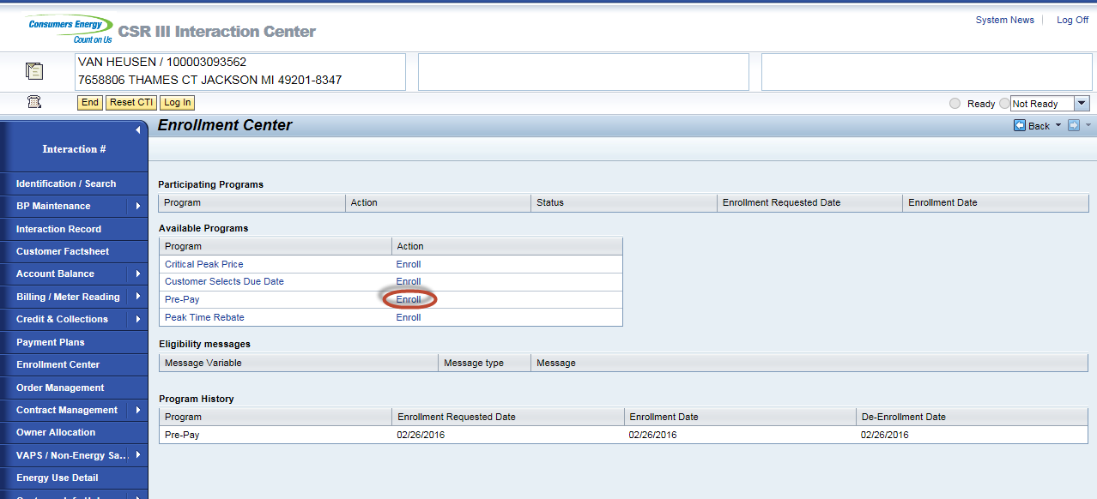
If PrePay shows ‘Ineligible’ link it could be due to the following reasons which will display under Eligibility messages when clicked.
Programs | Status | Text
Not an active Account | X | No active contract exists.
Multiple Account | X | Account has multiple active contract accounts.
Over The Air Meter | X | Not all devices are AMI enabled.
Life Support | X | Not eligible to enroll for PrePay.
Bill Consolidator | X | Not eligible to enroll for PrePay due to 'Name' (Checkfree, CitiBank, Cass, NISC, EDI - with paper invoice, EDI - no paper invoice, BillTrust).
Cust not on rate RS_1000 | X | Not eligible to enroll for PrePay. Rate 'XXX' 'Name'. (Examples Electric Choice, Dynamic Peak Pricing, Plug in Electric Vehicle, Time Of Day)
Cust not on rate A_250/A_260 | X | Not eligible to enroll for PrePay. Rate 'XXX' 'Name'. (Examples Gas Choice, Dynamic Peak Pricing, Time Of Day)
Facta Failure | X | Not eligible to enroll for PrePay until resolved.
PIR Contact | X | Not eligible to enroll for PrePay until resolved.
Collective Account | X | Not eligible to enroll for PrePay.
Green Generation | X | Not eligible to enroll for PrePay.
People Care | X | Not eligible to enroll for PrePay.
Net Metering | X | Not eligible to enroll for PrePay.
CARE 3.0 | X | Not eligible to enroll for PrePay.
Payment Plan | X | De-enroll customer from payment plan (BP, WPP, Or SPP)
Electric Past Due Balance | X | Past due balance must be below $200.00.
Combo Past Due Balance | X | Past due balance must be below $400.00.
Customer Selects Due Date | X | Need to change payment terms to CE21.
Cap Loan | X | Not eligible to enroll for PrePay.
Installment Plan | X | Need to de-enroll from installment plan to be eligible for PrePay.
Direct Pay | X | Customer will need to de-enroll from DP to be eligible for PrePay enrollment.
Recurring Card Payment | X | Customer will need to de-enroll from RCP to be eligible for PrePay enrollment.
iFactor | X | Billing and payment preferences need to be removed.

When enrolled link is clicked the Pre-Enrollment View Displays. CSR will read the information on the page to the customer. 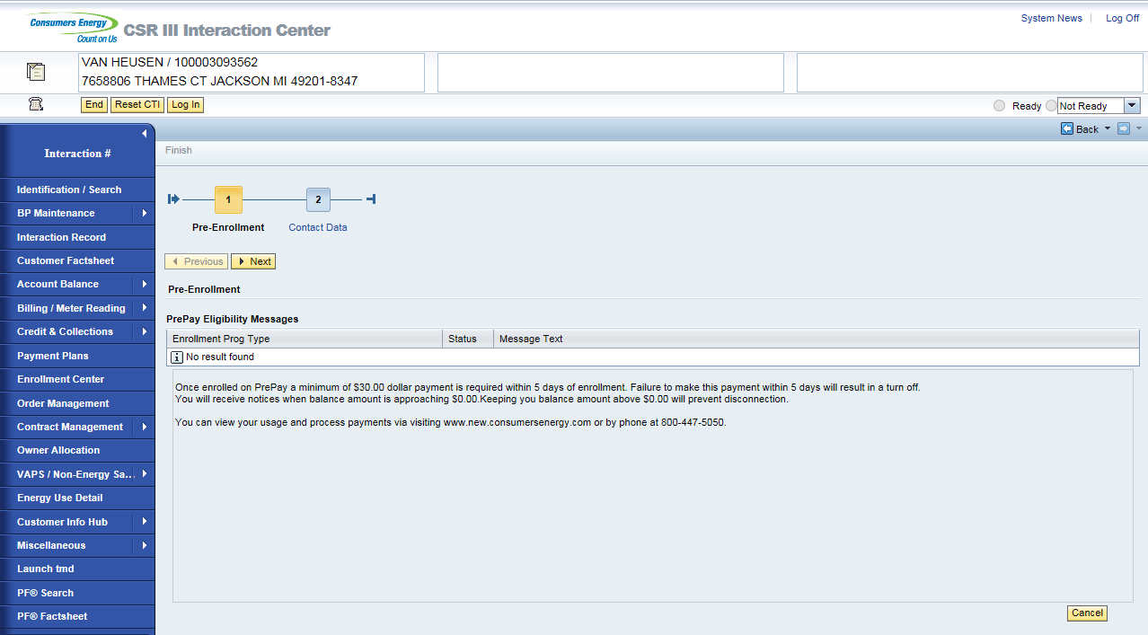
*Existing customer enrollment - customer with at least one bill, will display the following message on the Pre-Enrollment Screen:
“When enrolling in prepay, a new account number will be generated. Your previous account will be closed and a final bill will be issued which must be paid. If the balance is not paid, it will be transferred to your new account number, 20% of the amount the customer chooses to pay will be used toward the outstanding balance. 80% will then be applied to the prepay account for future use. All future payments are to be applied to the newly generated PrePay account. “

Warning messages will display under PrePay eligibility messages if the account is on any of the following. These messages do not prevent enrollment. This is information for the customer and CSR.

Program | Status | Text
Recurring Card Payment | Yellow Warning | Inform customer that final bill will be paid due to enrollment on RCP
Direct Pay | Yellow Warning | Inform customer that final bill will be paid due to enrollment on DP
Payment Plan | Yellow Warning | Inform customer that PrePay enrollment will auto de-enroll from (SPP, WPP, BPP)
Appliance Service Plan | Yellow Warning | Inform customer that their ASP plan will be canceled on enrollment.
If customer still wants their Appliance Service Plan, the CSR will need to complete the PrePay enrollment and enroll the
Customer into a plan that is not tied to their utility bill. PrePay enrollment process will need to be completed so the CSR
can enroll on the ASP plan using their new active Contract Account.
Once the information is provided to the customer, the CSR will click next button or Contact Data button to view the
Contact Data view.

CSR will need to collect a Preferred and Critical communication method.

- Email address is required for the Preferred Communication. A enrollment email, general account balance, information
and alerts will be sent to this email. This email can only be changed on the PayGo site once the enrollment is
completed.

- Email, Phone or Text is required for the Critical Communication. Low balance alerts and disconnection notifications
will be sent to the method that the customer has picked. Critical email address cannot be the same as the preferred.
Critical method can only be changed on the PayGo site once the enrollment is completed.
Once the Preferred and Critical methods are entered, the CSR will hit Submit.
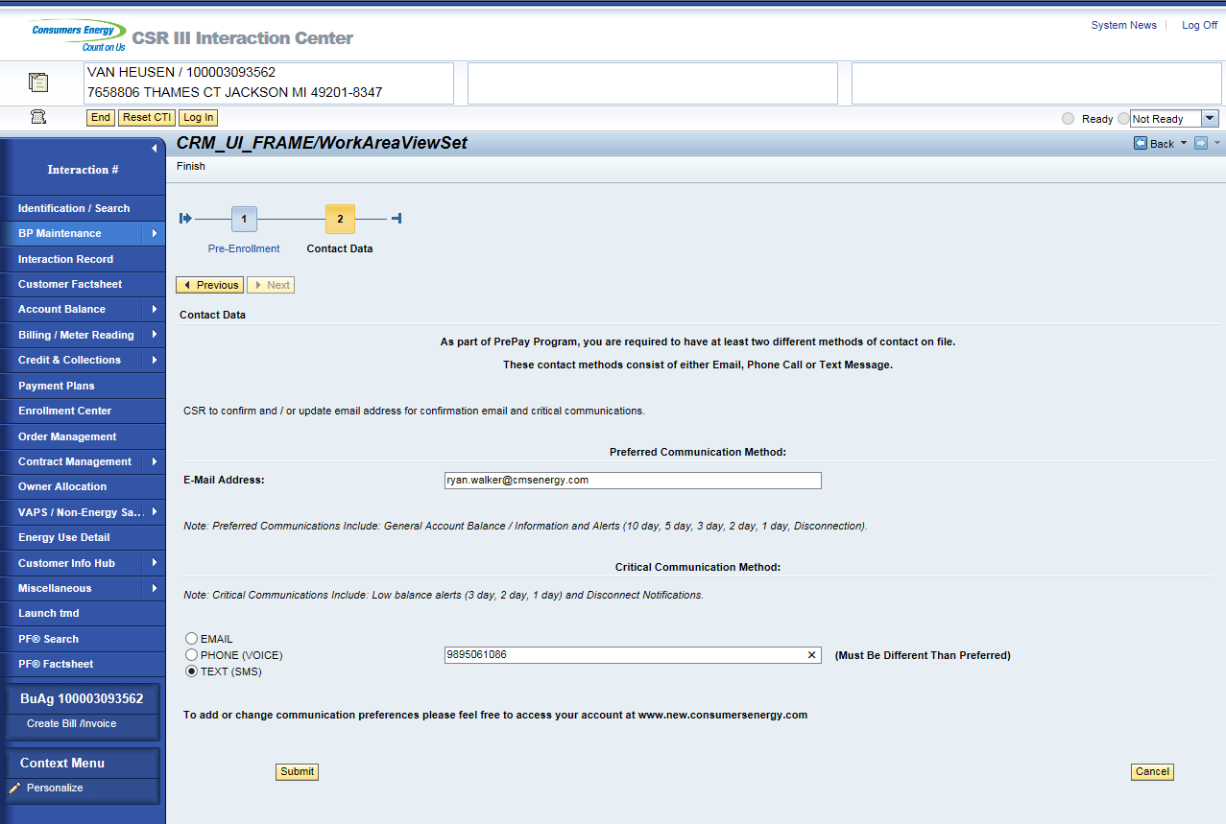
Summary Screen displays CSR will let the customer know that the enrollment is not completed until they receive there confirmation email. Contract Account number will display automatically when the enrollment has occurred for a new customer (Customer that has not been billed). Get CA button will display on the summary when it is an existing customer (Customer that has been billed). The CSR will click on the Get CA button to pull the Contract Account number. This button is needed due to timing needed for the workflow to process the new contract account in the back office. CSR’s will be able to click the Get CA button up to 3 times. If the third time fails to pull the contract account, the BP number will display.
New Customer:
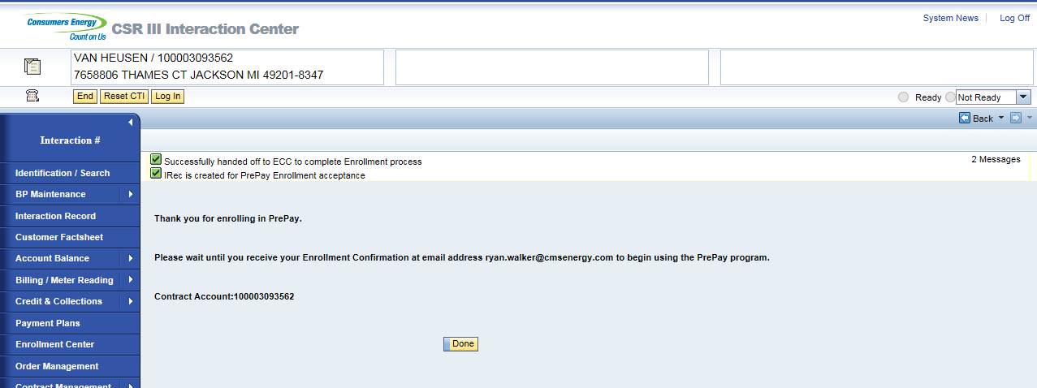
Existing Customer: Select Get CA button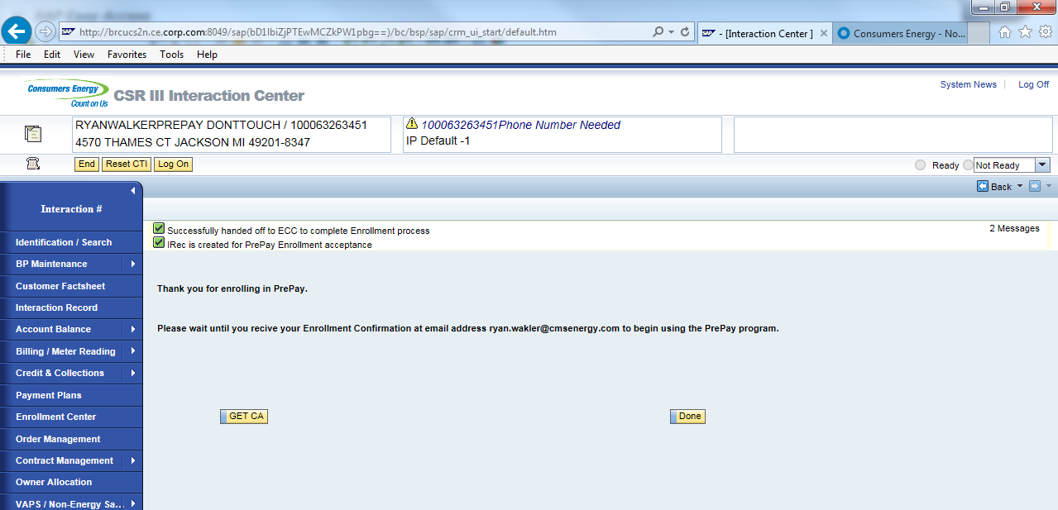
Account number displays.
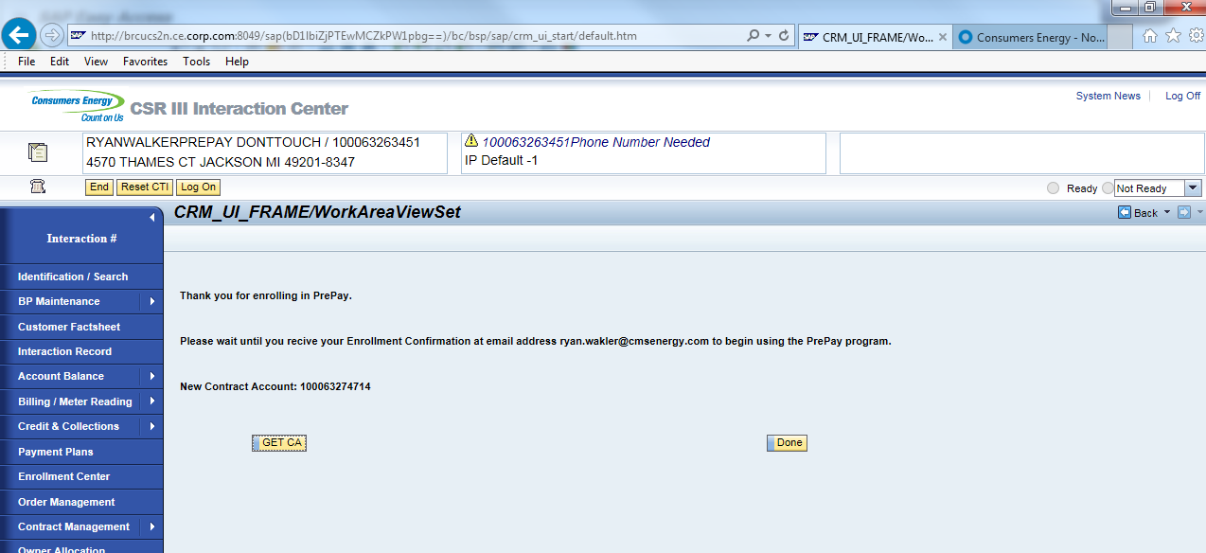
Clicking done on the summary screen will land on notification screen.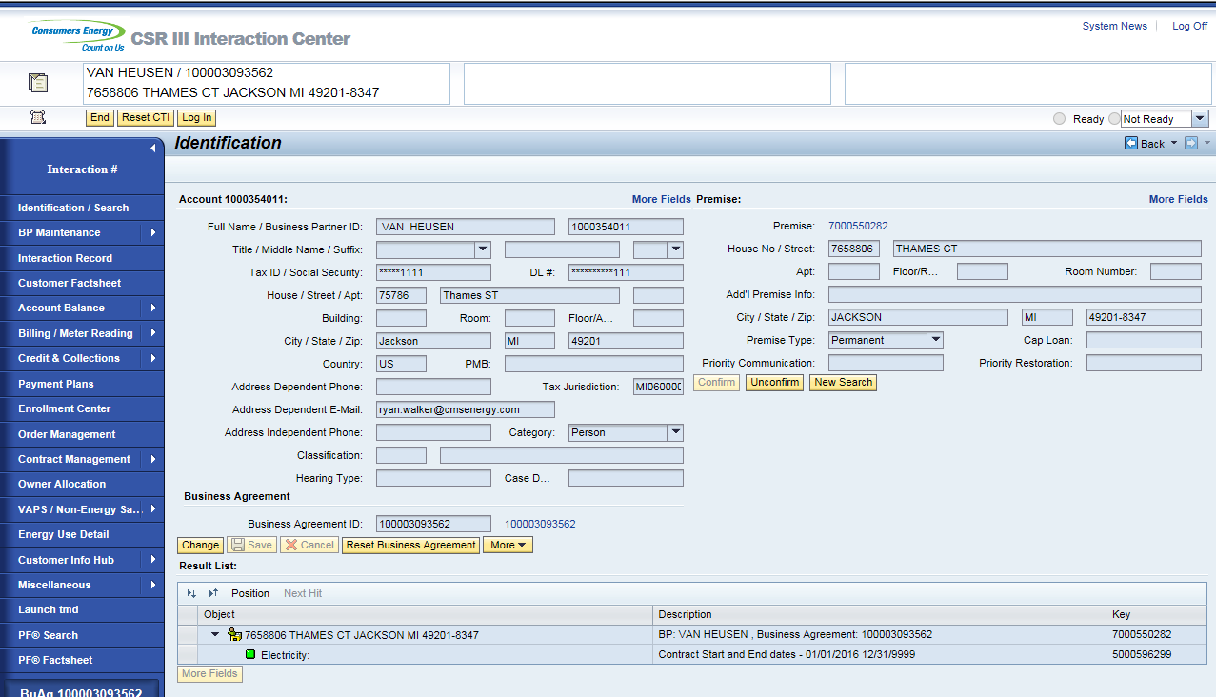
PrePay enrollment will process. If a meter read is not currently available on the account the enrollment will not trigger to PayGo system. Once the read is collected from the meter, the enrollment will process on PayGo side. This will also trigger the enrollment email to the customer notifying them that the enrollment is completed.

Enrollment Email:
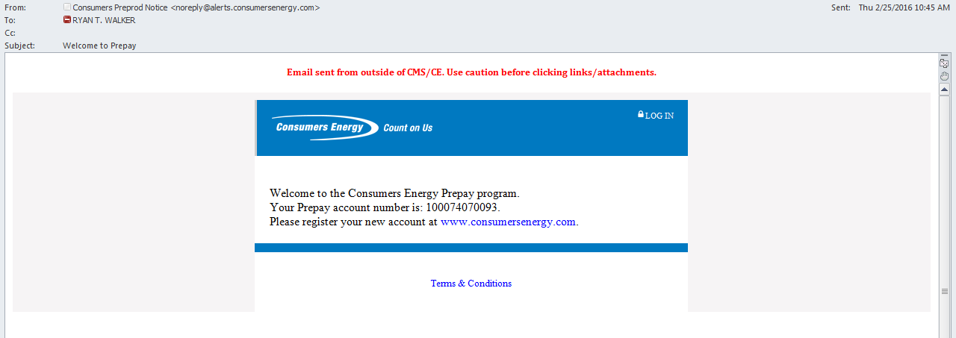
On enrollment, the Dunning procedure will update to CMS PrePay Customer Dunning procedure and Bill Consolidator will update to 0008 PrePay Account. This can be found by selecting the Business Agreement ID from the Identification / Search view and landing on the Business Agreement view.
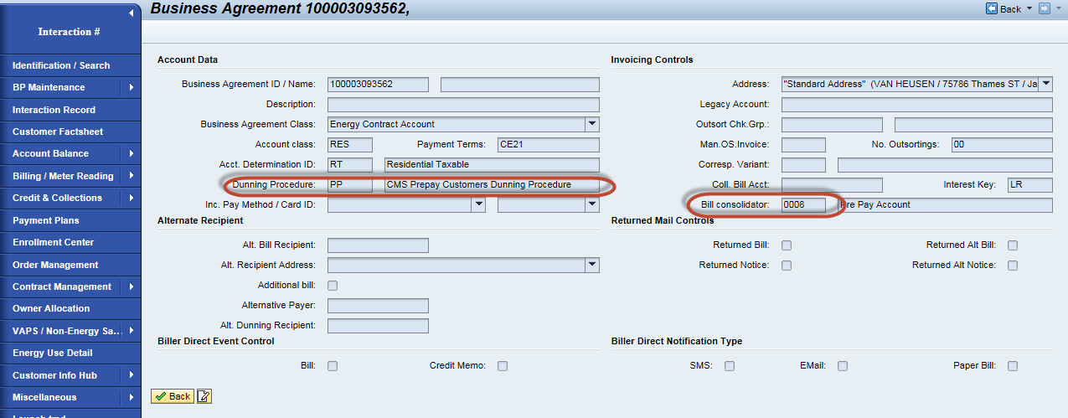
Confirming the account again in CRM and navigating to the enrollment center will show that the account is enrolled. 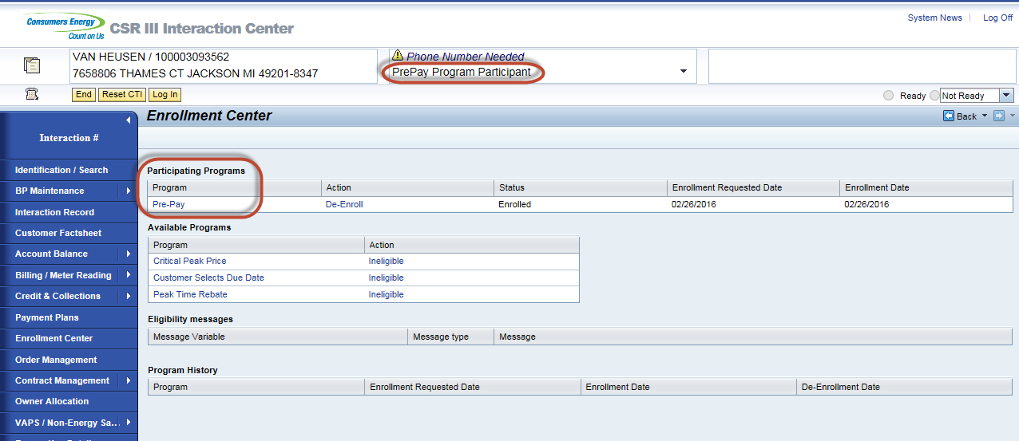
Interaction records are created. Selecting the Interaction Record from the navigation bar will display the interactions.
Enrollment Pending interaction is created on enrollment. It is pending interaction because we are waiting to receive
Confirmation back from PayGo.
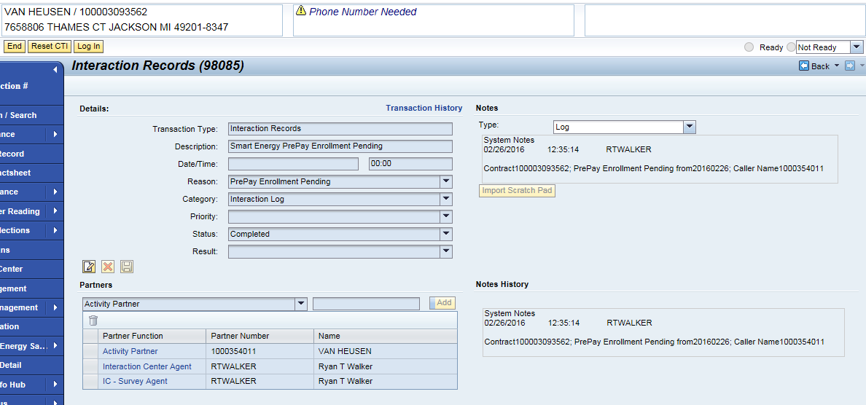
Enrollment Complete interaction is created when we receive confirmation back from PayGo. This update occurs on table ZTPPM_TXN_HIST.

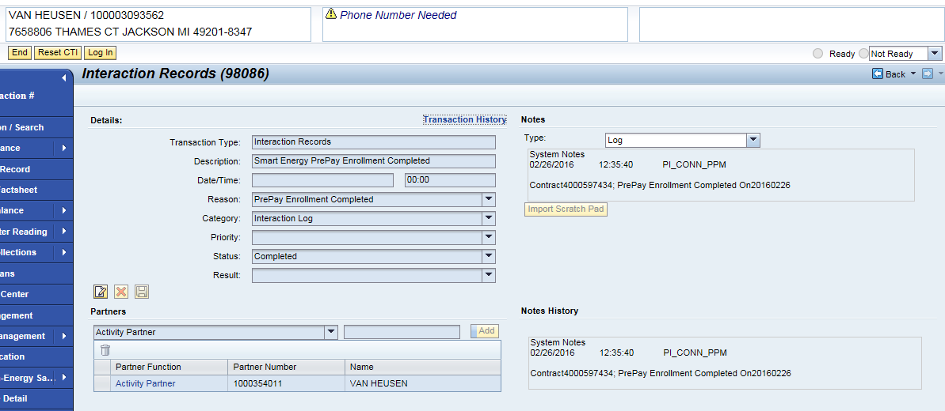
Enrollment Canceled interaction will be created when a de-enrollment occurs with a pending enrollment.

CRM PrePay Link to PayGo site:

Process describes how CSR’s will access the PayGo site.
Confirm Business Agreement 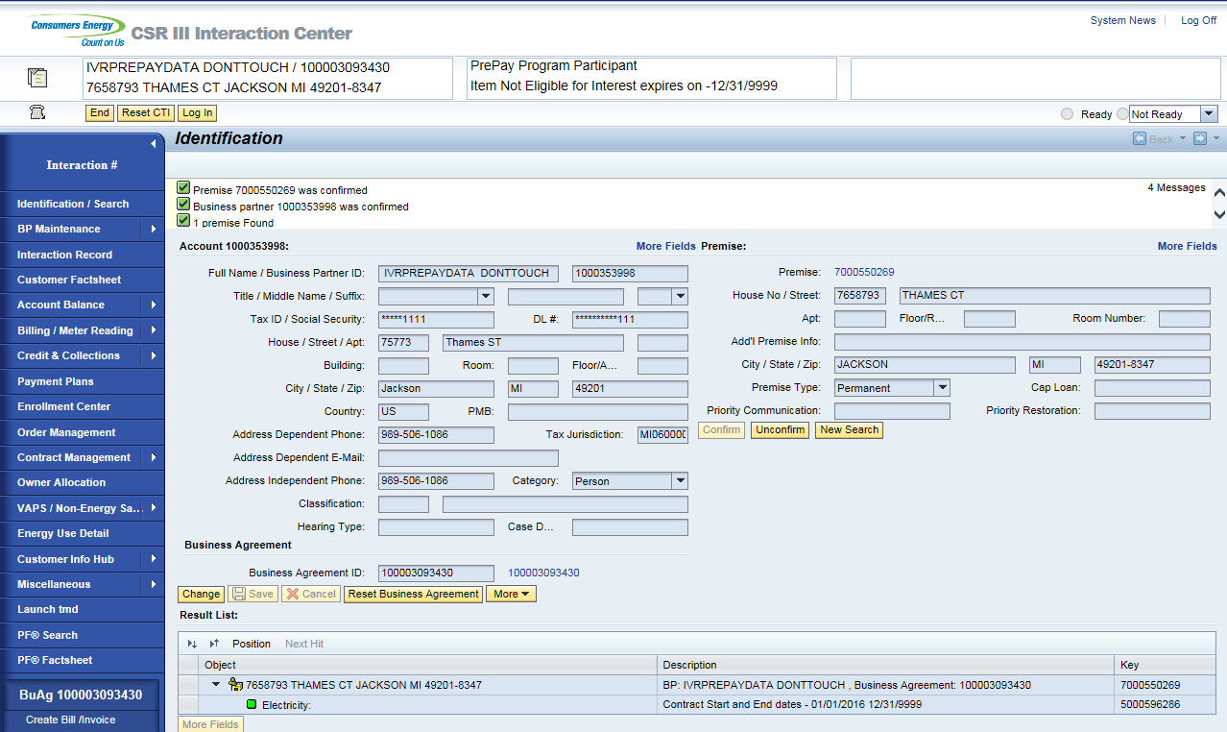

Click arrow next to Miscellaneous / Click on PrePay Portal
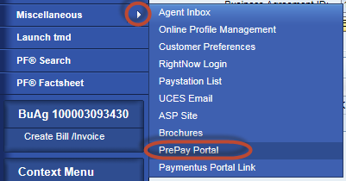
Land on PayGo site.
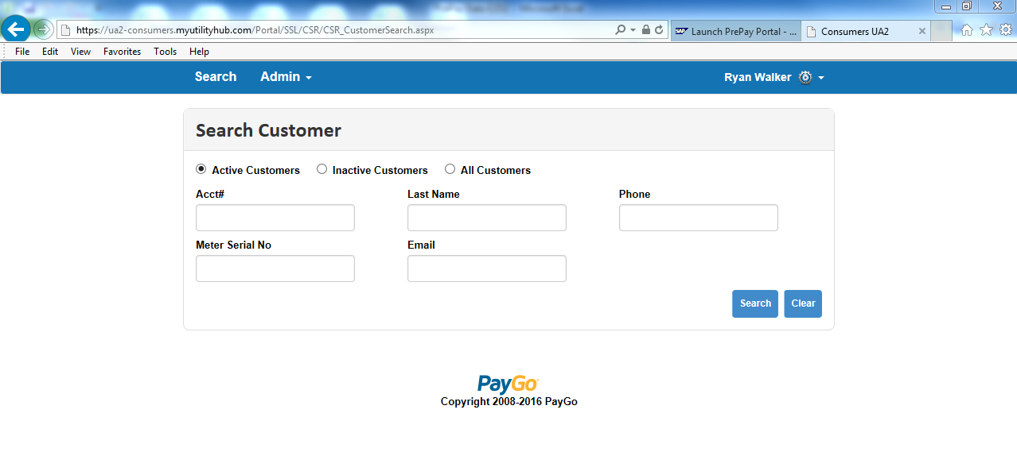

Search Business Agreement. Acct# is the Business Agreement/Contract Account number. Once search the CSR can click on the Acct# to display the account info.
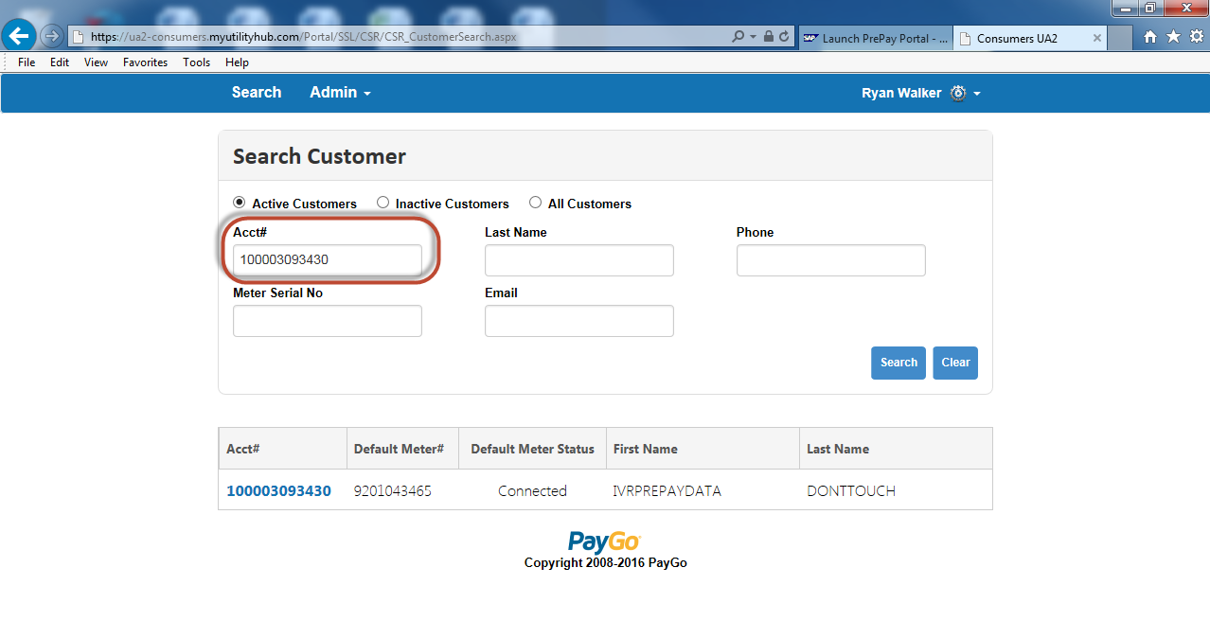

Account displays.
